**SOFTWARE REQUIREMENTS SPECIFICATION (SRS) FOR ORGAN DONOR AND FINDER WEBSITE (ODF)**

**1. Purpose**

The purpose of this document is to define the functional and non-functional requirements for the Organ Donor and Finder website (ODF). This website will help hospitals register patients as donors or place them on a waiting list to receive organs. It will display donor details such as age, blood group, and medical history, while maintaining donor anonymity.

**2. Scope**

The Organ Donor and Finder website is a web-based application that enables:

* Hospitals to add patients to organ waiting lists.
* Individuals to enlist themselves as organ donors with the help of an admin, who will verify details and register them on the website.
* The website to protect user identities but display relevant information related to each organ, such as medical history, blood group, age, and locality.
* The system to show the number of people on the waiting list for each organ.

**3. Benefits**

* Facilitates easier communication between hospitals and patients to find suitable organs and connect with the donor or hospital.
* Displays the availability of donor organs.
* Improves efficiency and accessibility.
* Reduces manual effort by allowing paperwork and meetings to be conducted online.

**4. User Classes and Characteristics**

* Admin (Hospital officials): Can view donor personal information, decide the recipient for donor organs, and remove people from the list based on medical history.
* User (Patients): Can view the number of people waiting for an organ and register themselves as donors with admin assistance.

**5. Specific Requirements**

**5.1 Functional Requirements**

* Login Module: Allows users and admins to log in to their accounts.
* Member Management: Admin can add or remove people from the donor list and move them up or down the priority list.
* Organ Management: Admin can add new donor organs along with necessary information.
* Search and Filter: Users and Admins can search for organs and filter results by blood group and locality.

**5.2 Non-functional Requirements**

* Performance: The system should process transactions in under 3 seconds.
* Security: Only authenticated users can access the system; users must not be able to access admin controls.
* Usability: The interface should be easy to use for both Admins and Users.
* Reliability: The web-based version should have 99% uptime.
* Scalability: The system should support future expansion.

**6. System Models**

**6.1 Use Case Diagram**

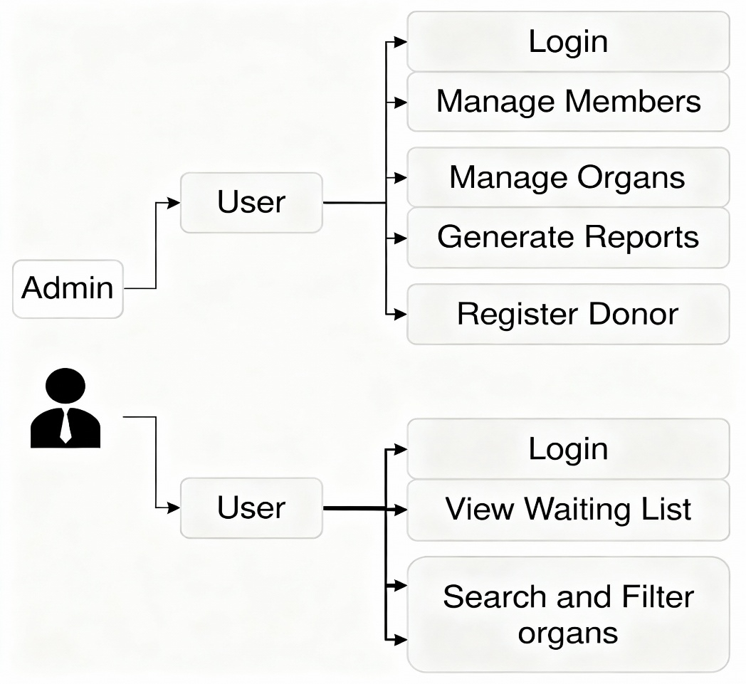

**Appendix**

**Future Scope**

* Expand worldwide to provide necessary organs to hospitals, even in remote areas.
* Add mobile app support.

**Limitations**

* Only works in certain areas; must be approved by governments before release in other locations